ASSIGNMENT-10
NAME: M.Sanjana
GROUP: CSE-AIML
COURSE: AI Assisted Coding
ENROLL NO: 2503A52709

Lab 10 – Code Review and Quality: Using AI to Improve Code
Quality and Readability

Task Description #1 – Syntax and Logic Errors
Task: Use AI to identify and fix syntax and logic errors in a faulty
Python script.
Sample Input Code:
# Calculate average score of a student
def calc_average(marks):
total = 0
for m in marks:
total += m
average = total / len(marks)
return avrage # Typo here
marks = [85, 90, 78, 92]
print(&quot;Average Score is &quot;, calc_average(marks)
Expected Output:
Corrected and runnable Python code with explanations of the
fixes.
Prompt:
Write a Python program to identify and fix syntax and logic errors in the given faulty code. Correct the indentation, fix the variable name typo, and add the missing closing parenthesis. Provide the corrected runnable code, explain the errors, and display the expected output.
Code:
def calc_average(marks):
total = 0
for m in marks:
total += m
average = total / len(marks)
return average

marks = [85, 90, 78, 92]
print("Average Score is", calc_average(marks))
Output:
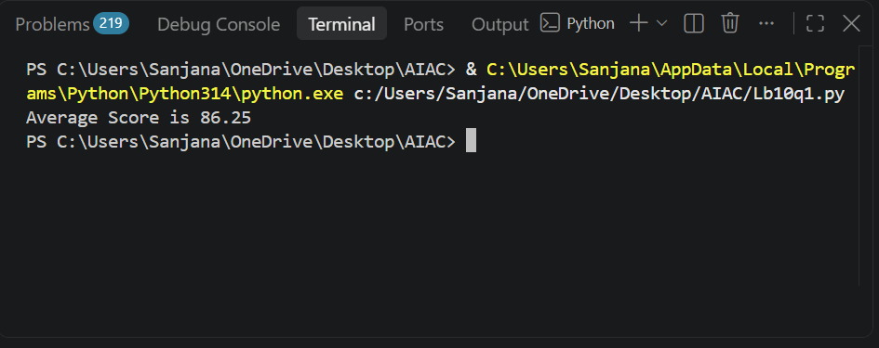

Task Description #2 – PEP 8 Compliance
Task: Use AI to refactor Python code to follow PEP 8 style
guidelines.
Sample Input Code:
def area_of_rect(L,B) : return L*B
print(area_of_rect(10,20))
Expected Output:
Well-formatted PEP 8-compliant Python code.
Prompt:
Refactor the given Python code to follow PEP 8 style guidelines. Use proper function naming, spacing, indentation, and line formatting. Provide the corrected, well-formatted Python code and its output.
Code:
def area_of_rect(length, breadth):
return length * breadth

print(area_of_rect(10, 20))
Output:
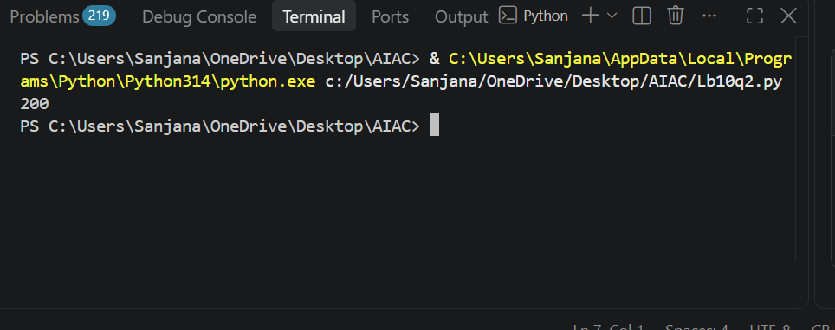

Task Description #3 – Readability Enhancement
Task: Use AI to make code more readable without changing its
logic.
Sample Input Code:
def c(x,y):
return x*y/100
a=200
b=15
print(c(a,b))
Expected Output:
Python code with descriptive variable names, inline
comments, and clear formatting.
Prompt:
Use AI to improve the readability of the given Python code without changing its logic. Replace short variable and function names with descriptive names, add meaningful inline comments, and apply proper indentation and formatting. Provide the improved Python code and its output.
Code:
# Calculate percentage of a value
def calculate_percentage(value, percentage):
# Calculate the required percentage
return value * percentage / 100

total_value = 200
percentage_value = 15

# Display the result
print(calculate_percentage(total_value, percentage_value))
Output:
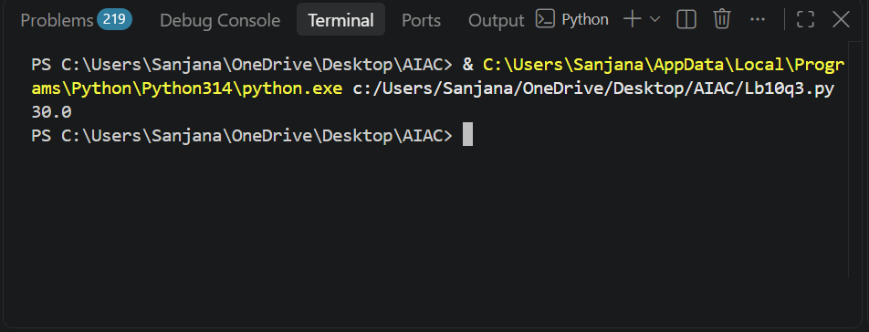

Task Description #4 – Refactoring for Maintainability
Task: Use AI to break repetitive or long code into reusable
functions.
Sample Input Code:
students = [&quot;Alice&quot;, &quot;Bob&quot;, &quot;Charlie&quot;]
print(&quot;Welcome&quot;, students[0])
print(&quot;Welcome&quot;, students[1])
print(&quot;Welcome&quot;, students[2])
Expected Output:
Modular code with reusable functions.
Prompt:
Refactor the given Python code to improve maintainability by breaking repetitive code into a reusable function. Create a function to display a welcome message for each student. Use a loop to process all students. Provide the modular Python code and its output without changing the original logic.
Code:
# Function to welcome a student
def welcome_student(name):
print("Welcome", name)

# List of students
students = ["Alice", "Bob", "Charlie"]

# Welcome all students
for student in students:
welcome_student(student)
Output:
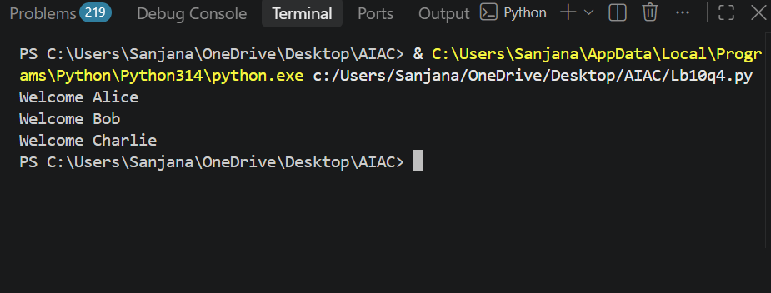

Task Description #5 – Performance Optimization
Task: Use AI to make the code run faster.
Sample Input Code:
# Find squares of numbers
nums = [i for i in range(1,1000000)]
squares = []
for n in nums:
squares.append(n**2)
print(len(squares))
Expected Output:
Optimized code using list comprehensions or vectorized
operations.
Prompt:
Optimize the given Python code to improve its performance. Use list comprehension or other efficient methods, remove unnecessary operations, and provide the optimized Python code with its expected output.
Code:
# Find squares of numbers
squares = [n**2 for n in range(1, 1000000)]

print(len(squares))
Output:
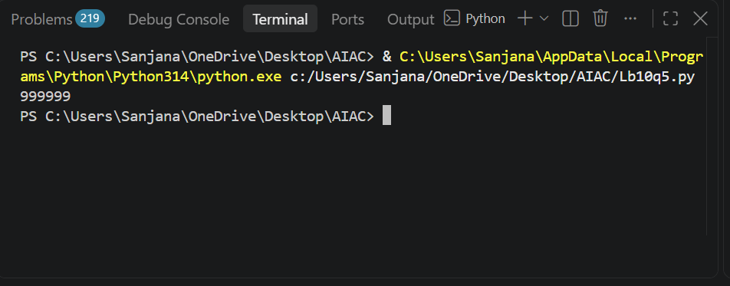

Task Description #6 – Complexity Reduction
Task: Use AI to simplify overly complex logic.
Sample Input Code:
def grade(score):
if score &gt;= 90:
return &quot;A&quot;
else:
if score &gt;= 80:
return &quot;B&quot;
else:
if score &gt;= 70:
return &quot;C&quot;
else:
if score &gt;= 60:
return &quot;D&quot;
else:
return &quot;F&quot;
Expected Output:
Cleaner logic using elif or dictionary mapping.
Prompt:
Simplify the given Python code by reducing complex nested if-else statements. Use elif statements or dictionary mapping to make the code cleaner and more readable without changing its logic. Provide the improved Python code and its expected output.
Code:
def grade(score):
if score >= 90:
return "A"
elif score >= 80:
return "B"
elif score >= 70:
return "C"
elif score >= 60:
return "D"
else:
return "F"

print(grade(95))
print(grade(85))
print(grade(75))
print(grade(65))
print(grade(50))
Output:
